Software Design and Development

The

Betting Pool

Static Scope

Colloquium Attendance Verification

|  |  |
| --- | --- |
| VERSION: 1 | REVISION DATE: 11.16.09 |

|  |  |  |  |
| --- | --- | --- | --- |
| **Approver Name** | **Title** | **Signature** | **Date** |
| Latanya Mattocks | Team Leader | Latanya Mattocks | 12/6/2019 |
| Kwabe Boateng | Team Member | Kwabe Boateng | 12/6/2019 |
| Richard Henyo | Team Member | Richard Henyo | 12/6/2019 |
| Maurice Smith | Team Member | Maurice Smith | 12/6/2019 |

# **Section 1. Overview**

## Purpose

This system is designated for our client’s betting pool organization. Our clients need a software to keep track of all bets placed by their customers, what they are betting on, and their payout based on the odds of their bet. Our clients also need to keep track of all transaction made on this platform as well as the customers information. Customers places bets on games each week. Customers pick from the available games scheduled each week. Bet can be placed on different aspects of a game: player stats, final scores, penalty yards, etc. Each earnings take a 10% fee which goes to the client’s company.  

## 1.2 Scope

The customer will first sign the agreement contracts in order to start bidding. Now the customer will have the access to enter their information, such as name, address, bank information, their selected team and or select player, and the amount they are betting on the team. After the customer enter their information, they will receive an account number. The customer can place bets on games each week, player stats, each quarter, and final score. The customer will be able to choose their payment options, such as cash, credit/debit cards, Cash App, and Paypal. The customer can pick scheduled games each week. The customer will be able to login into their account and view betting guidance. transaction history, updates on the game, and secure payment system.

# **Section 2. System Architecture**

# **Colloquium Attendance Verification Architecture**

# A user will need a computer and internet in order to access the website to place their bets. Once they open the website the user will have to create a username and password, or if already a member they need to login with their credentials. Once the user login their information will then be passed through the database. In order for a user to place their bets they must have their credit card or other payment options on file. The user will be able to check the schedules and listings of every team during the season.

# **Section 3. Software Use-Case Diagram & Class**

## 3.1 Software Use-Case Chart

## 

## 3.2 Software Class Diagram Chart

**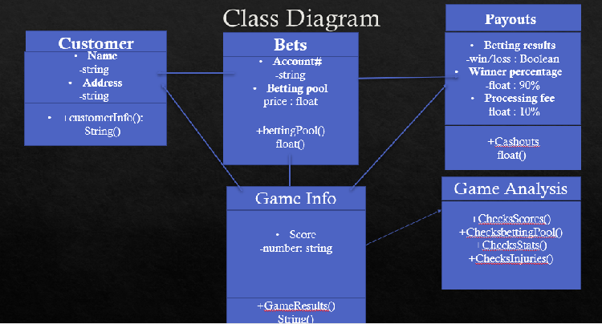**

#### 3.3.1.1 Component Log-In of User Interface

A user will log in via the user interface. Upon logging in, the user will be redirected to the home page or the admin user home page. The admin users will have the options to add a user to the system, remove a user from the system, view the bets in progress, view the payout for a win based on odds of the bet, and keep a transaction history of clients. The homepage for users is a view of schedule and listings, placing bets, and viewing their own payouts. They will also have an option to contact an administrator regarding their payouts and transaction.

##### A screenshot of a map Description automatically generated3.3.1.1.1 Class Person of Component Log in of Database User Interface

# **Section 4.** User Interface Design

## 4.1 User Interface Design Overview

**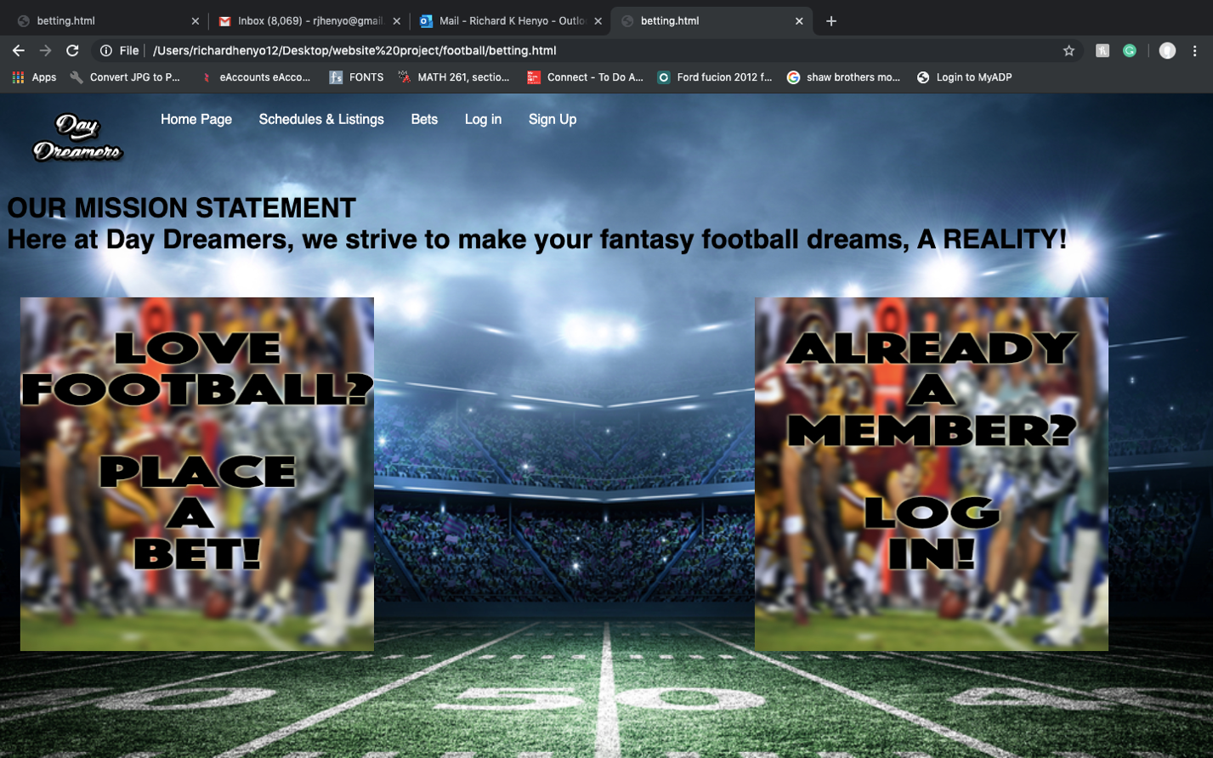Home Page**

**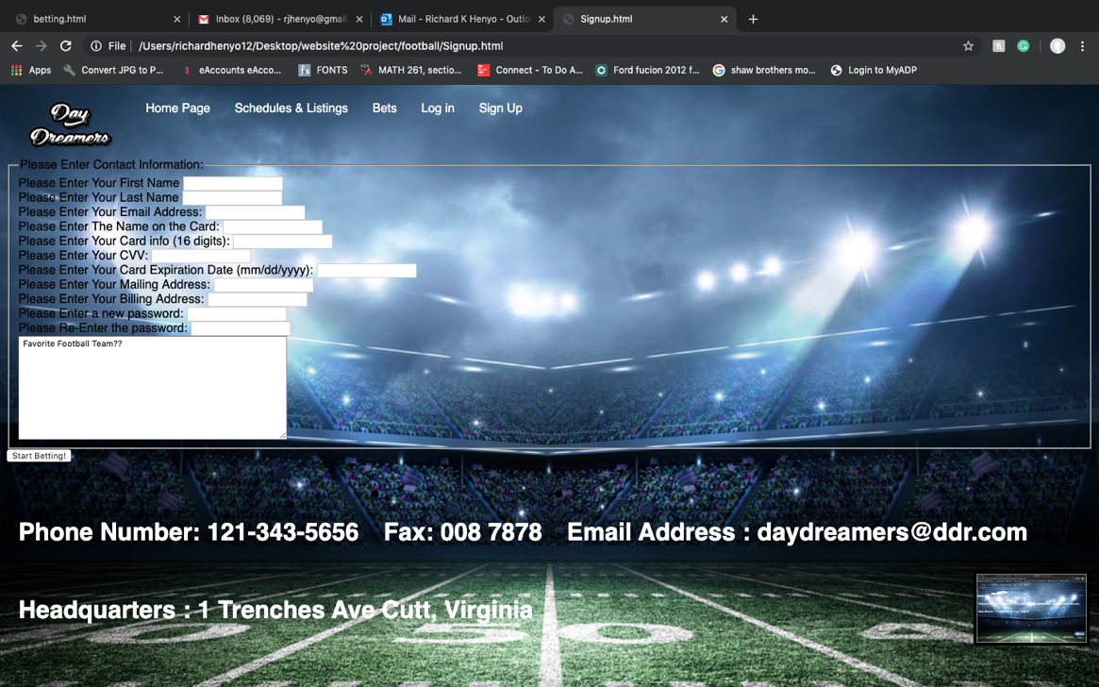New User Sign Up Page**

**New Member log in**

**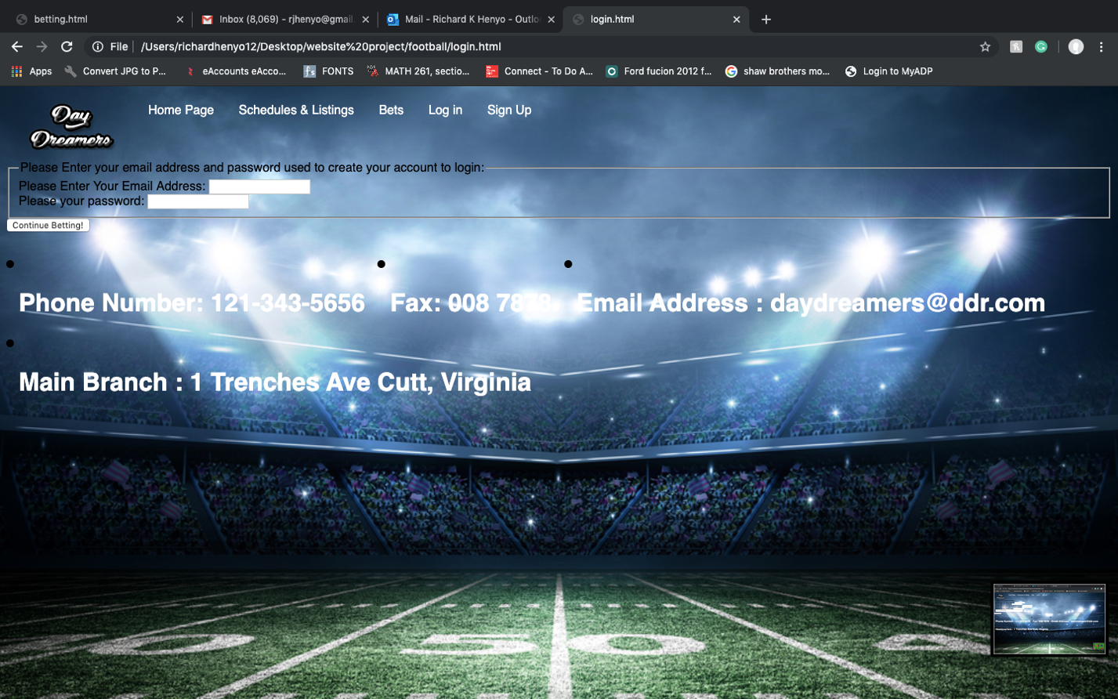**

**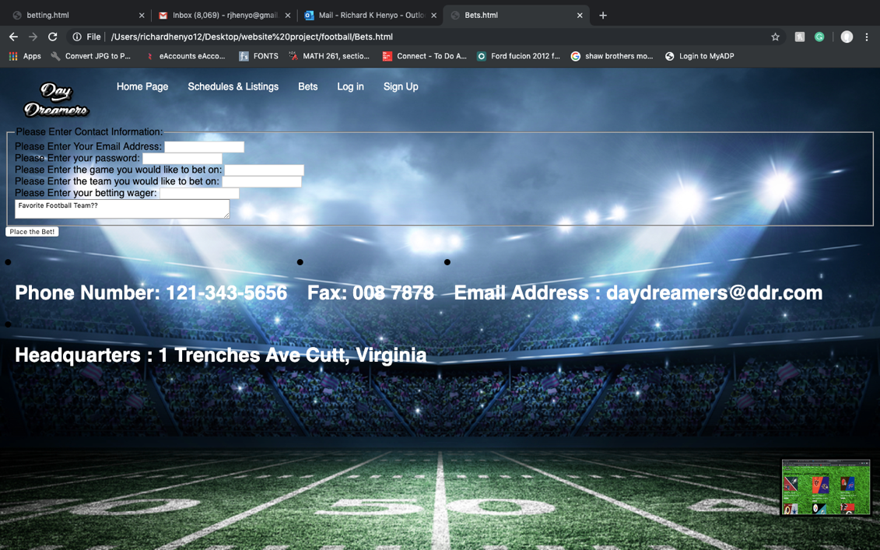Betting Page**

**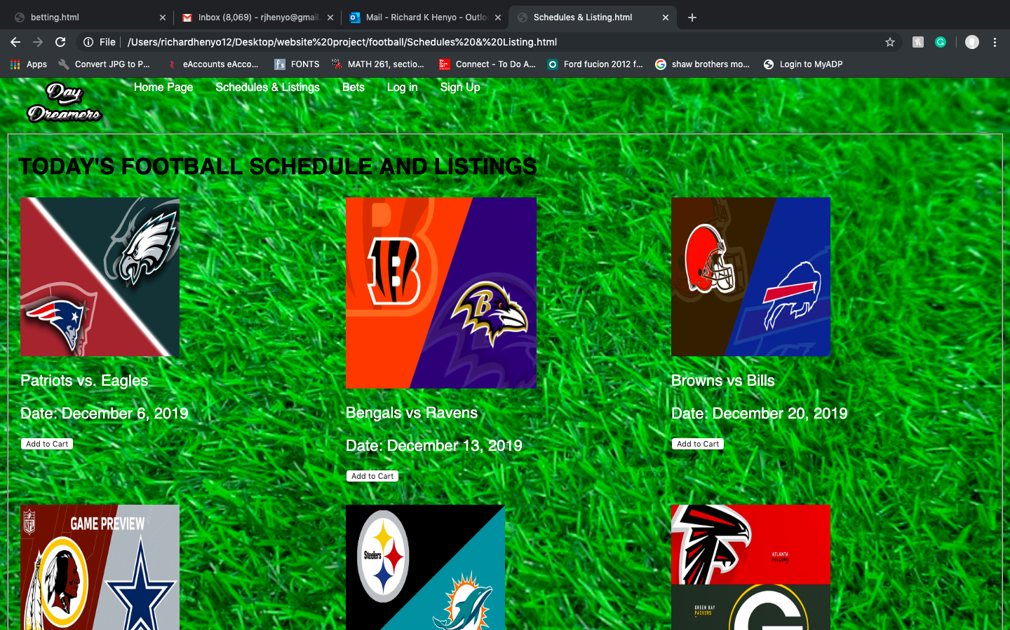Schedule and Listings**

**Usability**

Student users will need to have a basic knowledge of cellular phones and SMS messaging. All users accessing the web interface will need to have basic knowledge of computers and the internet in order to access the website and effectively use its functions.

**Performance**

The performance of the system will depend upon the user’s internet connection and computer speed. The interface will be simplistic to make it easily accessible for users with slow connections.

**Supportability**

The administrators will be responsible for necessary system updates. If the administrators would like more information attached to the student, want to change the interface, or want to make changes to the database they will have approved access to do so.

**Interface**

The main interface for user interactions will be the web interface which allows students to view their attendance record and administrators to view attendance records, edit attendance records, edit student information, add a user, and delete a user.

## 

## 4.2 User Interface Navigation Hierarchy

## 

## When the user enters the web address in the address bar of their web browser they will be directed to the main log-in page. Upon arriving at the log-in page the user will be required to enter their username and password. When a student user logs in they will be directed to their homepage which displays their attendance record. They will then be able to log out or contact an administrator regarding their record. When an administrator logs in they will be directed to their homepage which has a menu of options. They will be able to view a student’s attendance record, edit an attendance record, add a student, and delete a student as well as log out. If a user does not log out the time out feature will log them out.

## 7.3 User Function Categories

### 7.3.1 Log-In User Function

**User Function: Log-In**

**Preconditions: Enrolled**

**Actor Action**

1. This case begins when a user

navigates to the website.

1. The user will type in their username and

password into the designated fields.

1. User presses “Submit” button.

**System Action**

4. The user will be directed to their homepage.

#### 7.3.1.1 Log-In Function Fields

##### 

**7.3.2 Administrator View Attendance Function**

# 

**System Response**

2. The system brings up the student search page.

5. System displays the corresponding student’s attendance record.

User Function: Administrator View Attendance

Preconditions: Logged-In

**Actor Action**

1. This case begins when an administrator

selects the “View Attendance” option.

1. The user inputs the student’s name or

Banner id.

1. The user presses Search button.

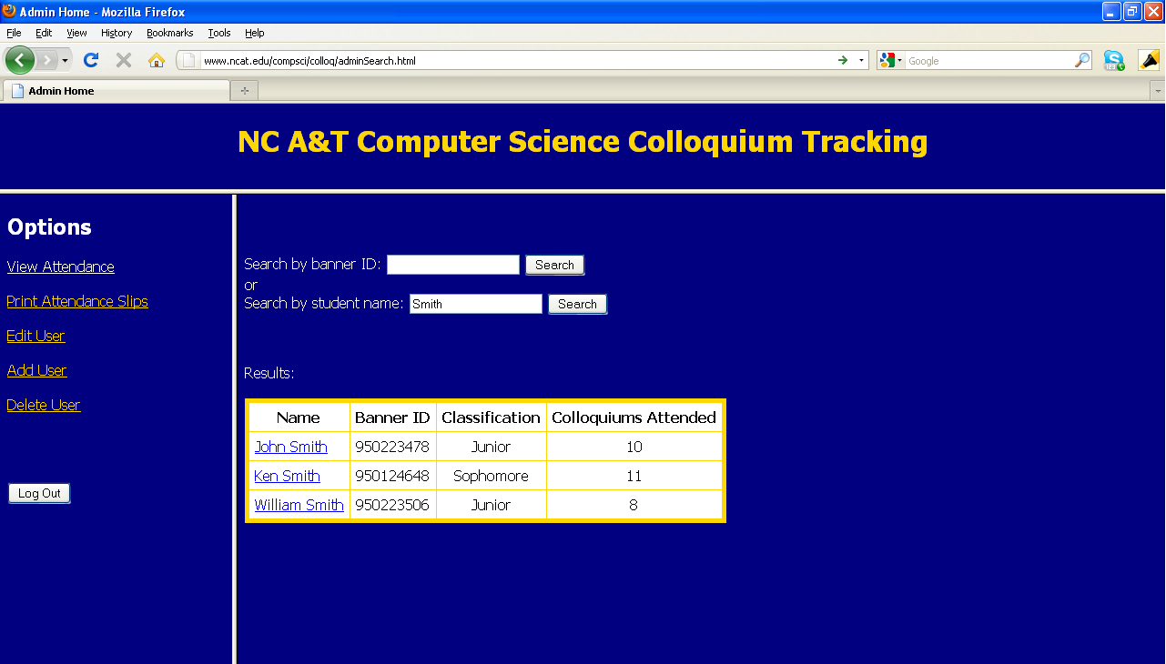 7.3.2.1 View Attendance Screenshots

# Student Search and Results

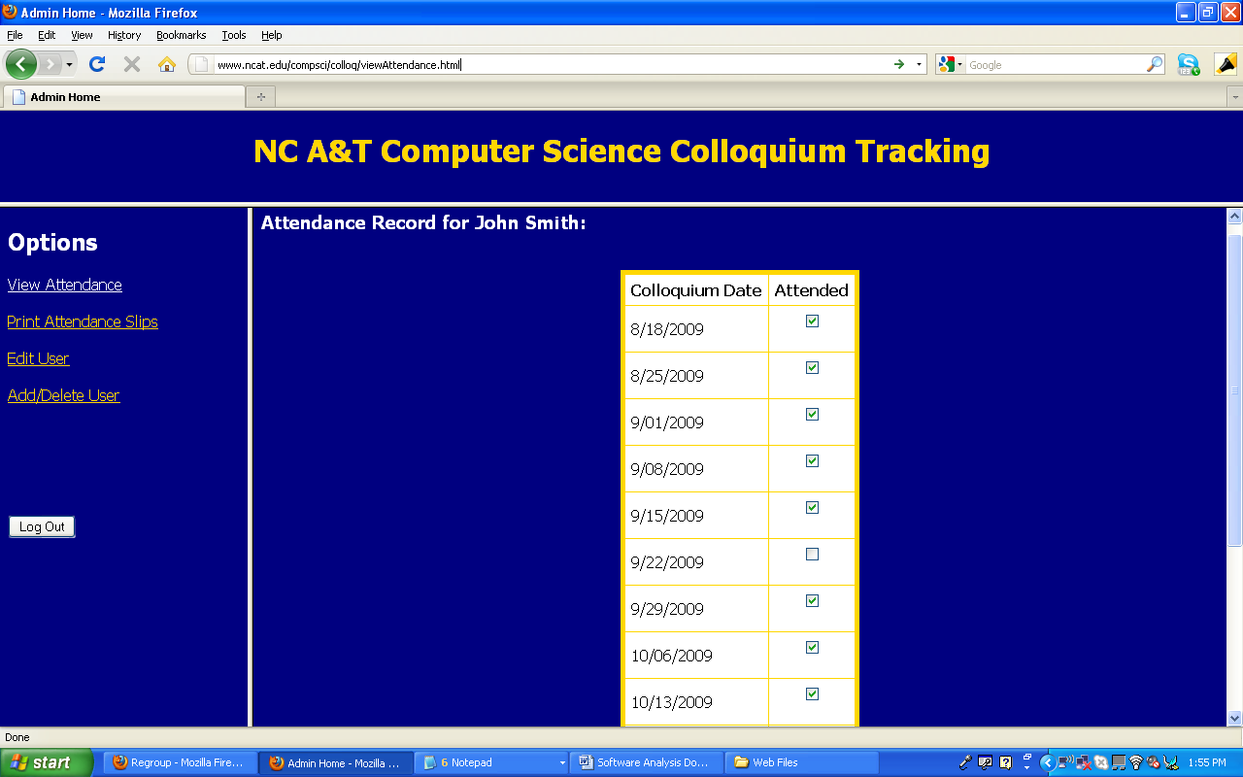View of student’s record.

**7.3.3 Administrator Add Student Function**

**System Response**

1. The system brings up the add

student page.

1. The information input by the user is added to the database.

User Function: Administrator Add Student

Precondition: Logged-In

**Actor Action**

1. This case begins when user selects the

“Add Student” function.

1. The user inputs student’s Banner ID, First

Name, Last Name, and Classification.

1. The user presses Submit.

# 7.3.3.1 Administrator Add Student Function Screenshot

# 7.3.3.1 Administrator Add Student Function Screenshot

# 

# 7.3.4 Administrator Delete Student Function

**System Action**

2. The system loads the delete student page.

4. The student is deleted from the system or the search results are displayed.

6. The student is deleted from the system.

User Function: Administrator Delete Student

Precondition: Logged-in

**Actor Action**

1. This case begins when the user selects

The “Delete Student” function.

1. The user inputs the desired student’s

Banner id or enters the student’s name

to search.

1. The user selects the desired student to

delete.

# 7.3.4.1 Administrator Delete Student Function Screenshot

# **7.3.4.1 Administrator Delete Student Screenshot**

# **Section 8. Other Interfaces**

## Email Interface

An email interface will be used to accept the SMS messages submitted by students in colloquium. The email client being used is Google’s Gmail. Gmail is able to accept the student’s text messages as emails which will then be parsed using Email2DB, an email-to-database parser (See 8.2).

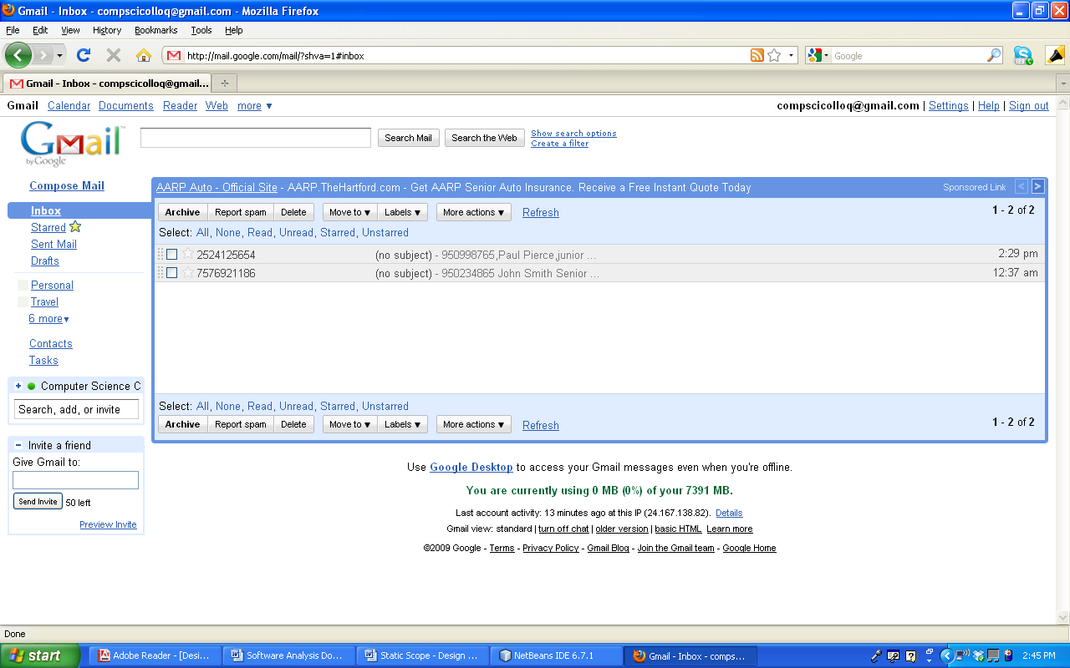Figure 5. Email Interface Screenshot

The email interface will only be accessible by administrator users, and will also be used in order to check a student’s attendance. In order to access Gmail the administrator will:

* Navigate to mail.google.com
* Enter compscicolloq for the username and ncataggies for the password
* Once the appropriate credentials are entered the user will be in the email interface.

## Email2DB (Email-to-Database Parser)

Email2DB is a free email-to-database parser that will parse the emails received from students and input the designated information into the database.

During the first colloquium class students will text into the system with their Banner id, first name, and last name so that their phone number will be attached to their record in the system. Email2DB will be programmed to parse the phone number and banner id from the messages received and pass the values to the database. When the values are passed the banner id will be used to ensure the telephone number is attached to the corresponding student.

**Section 10. Requirements Traceability Matrix**

# **Requirements_Matrix****Section 11. References**

| **Document No.** | **Document Title** | **Date** | **Author** |
| --- | --- | --- | --- |
| 1 | Dr. K. Williams, NC A&T Computer Science | 11-4-2009 |  |
| 2 | Professor G. Bullock, NC A&T Computer Science | 11-4-2009 |  |
|  | SDD Template | 11-09-2009 | Texas Project Delivery |
|  |  |  |  |
|  |  |  |  |

# 

# Section 13. Revision History

| **Version** | **Date** | **Name** | **Description** |
| --- | --- | --- | --- |
| 1.1 | 11-16-2009 | Candace, Joseph, Tashawna | First Revision |
|  |  |  |  |
|  |  |  |  |
|  |  |  |  |
|  |  |  |  |
|  |  |  |  |